**“MENTAL HEALTH COMPANION”**

**Project Report**

***Submitted by***

**Ansh Saraswat**

**22BCON416**

***In partial fulfilment for the award of the degree***

***of***

**BACHELOR OF TECHNOLOGY**

**IN**

**COMPUTER SCIENCE & ENGINEERING**

******At**

**JECRC UNIVERSITY, JAIPUR**

**MAY 2025**

**Acknowledgements**

Many people have supported me, in different ways, during the work with the thesis. I’d like to thank my guide **Ms.Megha Garg** & HOD **Dr.Bhavna Sharma** for their kind and active support and valuable guidance during the work process. My family has as always offered me their unconditional support, thank you! I have taken efforts in the Project. However, it would not have been possible without the kind support and many individuals and organizations. I would like to extend my sincere thanks to each and every members related to JECRC University.

**Ansh Saraswat**

**22Bcon416**

**Candidate’s Declaration**

I, **Ansh Saraswat** , bearing roll number **22Bcon416**, hereby declare that the work which is being presented in the Project, entitled “**Mental Health Companion**” in partial fulfilment for award of Degree of “**Bachelor of Technology**” in Department of **Computer Science Engineering** is submitted to the Department Computer Science & Engineering, JECRC University is a record of Project work carried under the Guidance of **Ms.Megha Garg**, Department of Computer Science & Engineering.

I have not submitted the matter presented in this work anywhere for the award of any other Degree.

**Ansh Saraswat**

**Computer Science Engineering**

**22Bcon416**

**JECRC UNIVERSITY JAIPUR**

Ramchandrapura, Sitapura Industrial Area Extn., Jaipur-303905(Raj.) India www.jecrcuniversity.edu.in

Date: 12.05.2025

**CERTIFICATE**

Certified that the Project Report entitled “**Mental Health Companion**” submitted by **Ansh Saraswat** bearing roll no. **22Bcon416** in partial fulfilment of the requirements for the award of the degree of Bachelor of Technology at JECRC University, Jaipur is a record of the student’s own work carried out under my supervision and guidance. To the best of my knowledge, this Project work has not been submitted to JECRC University or any other university for the award of the degree. It is further understood that by this certificate the undersigned does not endorse or approve of any statement made, opinion expressed or conclusion drawn therein but approve Project for the purpose for which it is submitted.

**Ms.Megha Garg**

(Project Guide)

**Ms.Neha Mishra Dr. Shashi Sharma**

(Project Coordinator) (Dy. HOD, CSE)

# TABLE OF CONTENTS Page

ACKNOWLEDGEMENTS ............................................................................................. 2

DECLARATION.............................................................................................................. 3

CERTIFICATE................................................................................................................. 4

ABSTRACT..................................................................................................................... 6

CHAPTER 1 – INTRODUCTION................................................................................... 7

CHAPTER 2 – LITERATURE SURVEY..................................................................... 12

CHAPTER 3 – SOFTWARE REQUIREMENT SPEC................................................. 16

CHAPTER 4 – SOFTWARE DESIGN.......................................................................... 17

CHAPTER 5 – SOFTWARE & HARDWARE REQUIREMENTS............................. 19

CHAPTER 6 – CODING/CODE TEMPLATES........................................................... 20

CHAPTER 7 – TESTING.............................................................................................. 24

CHAPTER 8 – ETHICAL CONSIDERATIONS.......................................................... 25

CHAPTER 9 – OUTPUT SCREENS............................................................................ 31

CHAPTER 10 – CONCLUSION................................................................................... 36

CHAPTER 11 – FUTURE ENHANCEMENTS........................................................... 39

YOUR PRIVACY, OUR PROMISE.............................................................................. 40

INDIVIDUAL CONTRIBUTIONS............................................................................... 41

REFERENCE................................................................................................................. 42

APPENDICES................................................................................................................ 43

# Abstract

The Mental Health Companion web application represents a proactive approach to supporting individual mental well-being through accessible and user-friendly digital tools. Recognizing the increasing importance of mental health and the limitations of traditional support systems, this project aimed to develop a web-based platform offering a range of features designed to promote self-reflection, emotional awareness, and mood management.

Developed using fundamental web technologies – HTML, CSS, and JavaScript – the application provides users with a private and convenient space to engage with practices such as journaling, guided relaxation (text-based placeholder), basic mood tracking, gratitude reflection, and self-care guidance. Additionally, a simple game (Tic Tac Toe) is included as a lighthearted tool for mood refreshment. This report outlines the conceptualization, design, development process, and potential impact of the Mental Health Companion,.

# CHAPTER 1 INTRODUCTION

In an increasingly fast-paced and demanding world, prioritizing mental health has become paramount. Statistics consistently highlight the widespread impact of mental well-being challenges on individuals across various demographics.

Traditional avenues for mental health support can often be hindered by factors such as cost, accessibility, and the persistent stigma surrounding mental health. Technology offers a promising avenue to bridge these gaps, providing individuals with convenient and private tools to support their emotional and psychological well-being.

The Mental Health Companion web application is conceived as such a tool, offering a collection of features designed to empower users to take a more active role in understanding and managing their mental state. This report details the development of this application, its core functionalities, the technologies employed (HTML, CSS, and JavaScript), and its potential to contribute to the growing landscape of digital

**Determinants of mental health**

Throughout our lives, multiple individual, social and structural determinants may combine to protect or undermine our mental health and shift our position on the mental health continuum.

Individual psychological and biological factors such as emotional skills, substance use and genetics can make people more vulnerable to mental health problems. Exposure to unfavourable social, economic, geopolitical and environmental circumstances – including poverty, violence, inequality and environmental deprivation – also increases people’s risk of experiencing mental health conditions.

Risks can manifest themselves at all stages of life, but those that occur during developmentally sensitive periods, especially early childhood, are particularly detrimental. For example, harsh parenting and physical punishment is known to undermine child health and bullying is a leading risk factor for mental health conditions.

Protective factors similarly occur throughout our lives and serve to strengthen resilience. They include our individual social and emotional skills and attributes as well as positive social interactions, quality education, decent work, safe neighbourhood and community cohesion, among others.

Mental health risks and protective factors can be found in society at different scales. Local threats heighten risk for individuals, families and communities. Global threats heighten risk for whole populations and include economic downturns, disease outbreaks, humanitarian emergencies and forced displacement and the growing climate crisis.

Each single risk and protective factor has only limited predictive strength. Most people do not develop a mental health condition despite exposure to a risk factor and many people with no known risk factor still develop a mental health condition. Nonetheless, the interacting determinants of mental health serve to enhance or undermine mental health.

The challenges associated with maintaining good mental health are multifaceted. Individuals often struggle with stress, anxiety, and fluctuations in mood, and may lack readily available, private, and cost-effective tools to address these issues proactively. Traditional mental health support, while crucial, may not always be immediately accessible or appealing to everyone. There is a clear need for resources that individuals can easily integrate into their daily lives to foster self-awareness, encourage positive coping mechanisms, and provide a sense of control over their emotional well-being.

**Mental health promotion and prevention**

Promotion and prevention interventions work by identifying the individual, social and structural determinants of mental health, and then intervening to reduce risks, build resilience and establish supportive environments for mental health. Interventions can be designed for individuals, specific groups or whole populations.

Reshaping the determinants of mental health often requires action beyond the health sector and so promotion and prevention programmes should involve the education, labour, justice, transport, environment, housing, and welfare sectors. The health sector can contribute significantly by embedding promotion and prevention efforts within health services; and by advocating, initiating and, where appropriate, facilitating multisectoral collaboration and coordination.

Suicide prevention is a global priority and included in the Sustainable Development Goals. Much progress can be achieved by limiting access to means, responsible media reporting, social and emotional learning for adolescents and early intervention. Banning highly hazardous pesticides is a particularly inexpensive and cost–effective intervention for reducing suicide rates.

Promoting child and adolescent mental health is another priority and can be achieved by policies and laws that promote and protect mental health, supporting caregivers to provide nurturing care, implementing school-based programmes and improving the quality of community and online environments. School-based social and emotional learning programmes are among the most effective promotion strategies for countries at all income levels.

Promoting and protecting mental health at work is a growing area of interest and can be supported through legislation and regulation, organizational strategies, manager training and interventions for workers.

**Mental health care and treatment**

In the context of national efforts to strengthen mental health, it is vital to not only protect and promote the mental well-being of all, but also to address the needs of people with mental health conditions.

This should be done through community-based mental health care, which is more accessible and acceptable than institutional care, helps prevent human rights violations and delivers better recovery outcomes for people with mental health conditions. Community-based mental health care should be provided through a network of interrelated services that comprise:

* mental health services that are integrated in general health care, typically in general hospitals and through task-sharing with non-specialist care providers in primary health care;
* community mental health services that may involve community mental health centers and teams, psychosocial rehabilitation, peer support services and supported living services; and
* services that deliver mental health care in social services and non-health settings, such as child protection, school health services, and prisons.

The vast care gap for common mental health conditions such as depression and anxiety means countries must also find innovative ways to diversify and scale up care for these conditions, for example through non-specialist psychological counselling or digital self-help.

**WHO response**

All WHO Member States are committed to implementing the [“Comprehensive mental health action plan 2013–2030"](https://www.who.int/publications/i/item/9789240031029), which aims to improve mental health by strengthening effective leadership and governance, providing comprehensive, integrated and responsive community-based care, implementing promotion and prevention strategies, and strengthening information systems, evidence and research. In 2020, WHO’s [“Mental health atlas 2020”](https://www.who.int/publications/i/item/9789240036703) analysis of country performance against the action plan showed insufficient advances against the targets of the agreed action plan.

WHO’s [“World mental health report: transforming mental health for all”](https://www.who.int/publications/i/item/9789240049338) calls on all countries to accelerate implementation of the action plan. It argues that all countries can achieve meaningful progress towards better mental health for their populations by focusing on three “paths to transformation”:

* deepen the value given to mental health by individuals, communities and governments; and matching that value with commitment, engagement and investment by all stakeholders, across all sectors;
* reshape the physical, social and economic characteristics of environments – in homes, schools, workplaces and the wider community – to better protect mental health and prevent mental health conditions; and
* strengthen mental health care so that the full spectrum of mental health needs is met through a community-based network of accessible, affordable and quality services and supports.

WHO gives particular emphasis to protecting and promoting human rights, empowering people with lived experience and ensuring a multisectoral and multistakeholder approach.

WHO continues to work nationally and internationally – including in humanitarian settings – to provide governments and partners with the strategic leadership, evidence, tools and technical support to strengthen a collective response to mental health and enable a transformation towards better mental health for all.

# CHAPTER 2 LITERATURE SURVEY

Various mobile and web applications like Headspace, Calm, BetterHelp, and Talkspace have attempted to provide digital solutions for mental health. Studies show mixed effectiveness, highlighting the need for personalization and user engagement. This chapter reviews academic research and existing tools, analyzing their strengths and limitations, and how the proposed Mental Health Companion builds upon these insights by offering a simple yet effective tool using lightweight frontend technologies.

**Introduction**

Mental health is an integral part of overall well-being, influencing emotions, thoughts, and behaviors. Various studies have highlighted the importance of companionship in improving mental health. Whether through human relationships or artificial intelligence-based companions, social support plays a crucial role in alleviating stress, anxiety, and depression.

**The Role of Companionship in Mental Health**

Research has extensively examined how companionship—whether through friends, family, pets, or AI-driven assistants—affects mental health. Studies indicate that social connections reduce feelings of loneliness and enhance emotional resilience. According to John Cacioppo’s (2008) work on loneliness, strong social bonds can help mitigate psychological distress and improve overall life satisfaction.

Companion animals have been widely recognized for their positive impact on mental health. A study by Herzog (2011) notes that pet ownership can reduce stress and promote emotional well-being. Similarly, technological advancements have introduced AI-based mental health companions that provide interaction, emotional support, and even therapy guidance.

**AI-Powered Mental Health Companions**

With increasing reliance on technology, AI-driven companions have gained attention for their potential in mental health care. AI chatbots designed for therapeutic interaction, such as Woebot and Wysa, use cognitive behavioral therapy (CBT) techniques to help individuals manage stress and anxiety. Studies by Fulmer et al. (2018) and Bendig et al. (2019) suggest that AI mental health companions can complement traditional therapeutic interventions.

**Gaps in Existing Research**

While studies acknowledge the benefits of companionship in mental health, challenges remain in integrating AI-based solutions effectively. Key concerns include the ethical implications of AI companionship, privacy issues, and the effectiveness of long-term AI interactions compared to human relationships. Future research should explore the balance between human support and AI interventions in mental health care.

**Conclusion**

Companionship, whether human or artificial, plays a crucial role in mental health management. Existing literature highlights the psychological benefits of strong social connections and the potential of AI-driven companions. As technology continues to evolve, further research can help refine AI interventions and maximize their effectiveness in promoting mental well-being.

**Proposed Solution- The Mental Health Companion Web Application**

The Mental Health Companion is envisioned as a user-centric web application designed to be a personal tool for mental well-being. Its core concept revolves around providing a collection of simple yet effective features within a private and easily accessible environment – the user's own web browser. The target audience includes individuals who are seeking basic tools for self-reflection, mood management, and relaxation that they can use at their own pace and in the privacy of their own space.

Developed exclusively using HTML for structuring the content, CSS for styling and layout, and JavaScript for interactivity, the application prioritizes simplicity and accessibility. The absence of a backend database or external API integration ensures that all user interactions and any data generated (such as journal entries or mood logs, if persistence were implemented locally) remain within the user's browser, addressing potential privacy concerns.

**Detailed Description of Key Features**

* **Journal Entry -** This feature provides a straightforward text area where users can write about their thoughts, feelings, and experiences. The act of journaling has been shown to help individuals process emotions, gain clarity, and reduce stress. The interface is designed to be clean and uncluttered, encouraging focused writing. *(Placeholder for Screenshot of the Journal Entry interface)*
* **Guided Meditation -** Currently implemented as a section providing textual instructions for basic mindfulness or relaxation exercises, this feature serves as a placeholder for potential future integration of audio-based guided meditations (if local audio files were to be included). The aim is to guide users through simple practices that can promote calmness and reduce anxiety. *(Conceptual diagram of a simple text-based meditation instruction screen)*
* **AI Chat -** This feature utilizes basic JavaScript to simulate a simple conversational agent. Users can type in questions or statements and receive pre-programmed responses offering encouragement, general information related to well-being, or suggestions for utilizing other features of the application. It is crucial to emphasize that this is not a substitute for professional help but rather a basic interactive element for initial support. *(Placeholder for Screenshot of the AI Chat interface)*
* **Mood Tracker -** This feature allows users to log their current mood by selecting from a predefined set of options (e.g., happy, sad, anxious, calm). Over time, this can help users become more aware of their emotional patterns and potential triggers. While the current implementation lacks persistent storage and visual representation, the basic functionality of mood logging is present. *(Conceptual bar graph illustrating a week's worth of mood entries)*
* **Gratitude Journal -** This feature provides a dedicated space for users to list things they are grateful for. Practicing gratitude has been linked to increased happiness and a more positive outlook on life. The interface consists of a simple text area for users to record their gratitudes. *(Placeholder for Screenshot of the Gratitude Journal interface)*
* **Relaxation Exercises -** This section offers a collection of simple, text-based instructions for various relaxation techniques, such as deep breathing exercises or progressive muscle relaxation. These exercises can be used by users to quickly manage stress and promote a sense of calm. *(Conceptual flowchart outlining the steps of a deep breathing exercise)*
* **Self-Care Tips -** This section presents users with a curated list of general self-care suggestions across different domains (e.g., physical activity, healthy eating, social connection, mindfulness). The tips are intended to inspire users to prioritize activities that support their overall well-being.
* **Basic Game for Mood Refresh (Tic Tac Toe) -** Included as a lighthearted distraction, the Tic Tac Toe game, implemented entirely with HTML, CSS, and JavaScript, offers a simple way for users to take a break and potentially shift their focus away from negative thoughts or feelings. *(Placeholder for Screenshot of the Tic Tac Toe game interface)*

# CHAPTER 3 SOFTWARE REQUIREMENT SPECIFICATION

**Functional Requirements**  
- User journaling with local storage  
- Mood tracking system using emojis or icons  
- Simple guided meditation videos embedded  
- Interactive relaxation games  
- Simple AI chatbot simulation  
 **Non-Functional Requirements**  
- Responsive web design  
- Compatibility with modern browsers  
- Lightweight frontend implementation without backend  
 **Technology Stack**- HTML for structure  
- CSS for styling  
- JavaScript for interactivity

# CHAPTER 4 SOFTWARE DESIGN

The Mental Health Companion is designed as a client-side web application, meaning all the code runs directly in the user's web browser. This architecture, necessitated by the exclusive use of HTML, CSS, and JavaScript, has implications for data persistence and advanced functionalities.

* **Overall Structure -** The application is structured as a single HTML page that dynamically updates its content based on user interactions, a common approach for single-page applications (SPAs) built with JavaScript. HTML provides the semantic structure, CSS handles the visual presentation, and JavaScript manages the interactive behavior of the different features. *(Simple block diagram showing HTML, CSS, and JavaScript interacting within a web browser)*
* **User Interface (UI) Design -** The UI prioritizes simplicity and ease of use, aiming to create a welcoming and non-intrusive environment. The navigation, as seen in the provided screenshot, is clear and allows users to easily access each of the application's features. The color scheme and typography are chosen to promote a sense of calm and focus. *(Annotated screenshot of the main interface highlighting the navigation bar and the introductory text)*
* **Feature Implementation (Conceptual) -**
  + **Journal:** JavaScript handles the input from the text area. In a more advanced version with local storage, JavaScript would also be responsible for saving and retrieving entries within the browser.
  + **Meditation:** JavaScript could potentially control the display of different text-based meditation instructions or manage the playback of local audio files if implemented.
  + **Chat AI:** JavaScript contains the logic for matching user input with predefined responses and updating the chat interface.
  + **Mood Tracker -** JavaScript records the user's mood selection. More advanced front-end implementations could use JavaScript libraries to create simple charts visualizing mood trends based on temporary in-browser data.
  + **Gratitude Journal -** Similar to the journal, JavaScript manages text input and could handle local storage if implemented.
  + **Relaxation Exercises -** JavaScript might control the display of different exercise instructions or manage timers for specific techniques.
  + **Self-Care Tips -** JavaScript could be used to dynamically display a random selection of tips from a predefined list within the script.
  + **Tic Tac Toe -** The entire game logic, including handling user moves, checking for wins, and updating the game board, is implemented in JavaScript, with HTML providing the structure of the board and CSS handling its styling
  + **Help -** Redirects the user to an official government website dedicated to mental health resources. This ensures that users seeking assistance are provided with reliable, authentic information and support services. The government site offers access to expert advice, mental health programs, helpline numbers, and other tools aimed at promoting psychological well-being. By integrating this feature, the platform demonstrates a commitment to user welfare and responsible guidance.

# CHAPTER 5 SOFTWARE & HARDWARE REQUIREMENTS

**Software**  
- Web browser (Chrome, Firefox, Edge)  
- Any text editor (VSCode, Sublime Text)

**Hardware**  
- Any PC or laptop capable of running a modern web browser

No additional backend server or cloud infrastructure required for the frontend version.

# CHAPTER 6 CODING / CODE TEMPLATES

The project uses a modular HTML structure where each section is separated into div containers. CSS handles responsive layouts and theme colors. JavaScript is used for DOM manipulation, storing journal entries in local storage, updating mood icons, and simple game logic.  
  
**Code Snippet for adding a Journal Entry**

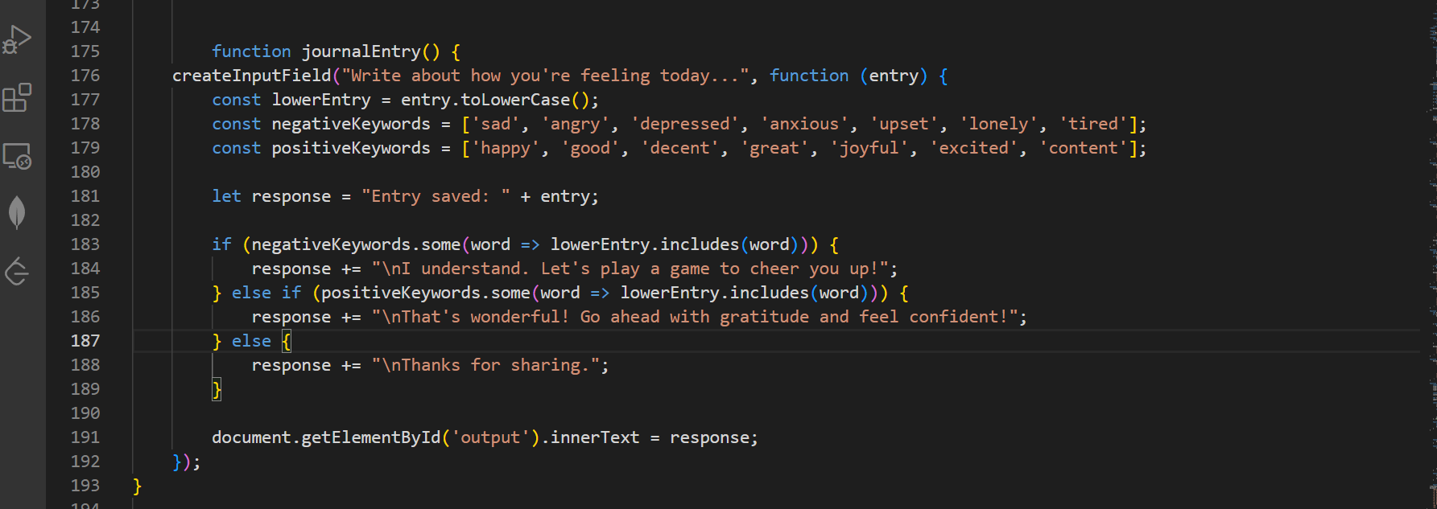

**Code Snippet for Guided Meditation Button**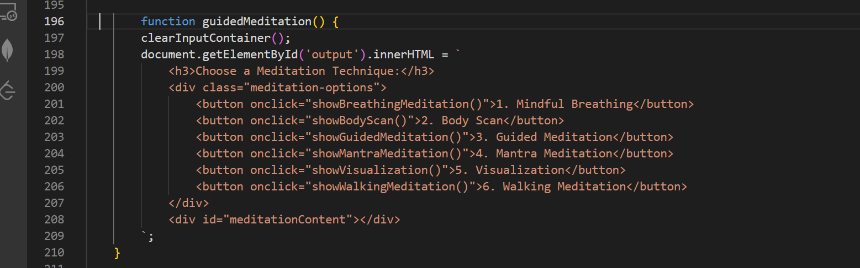

**Code Snippet for AI ChatBot**



**Code Snippet for Mood Tracker Button**

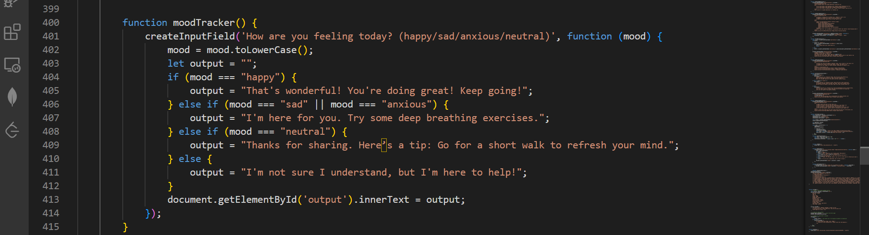

**Code Snippet for Gratitude Journal Button**



**Code Snippet for Relaxation Button**

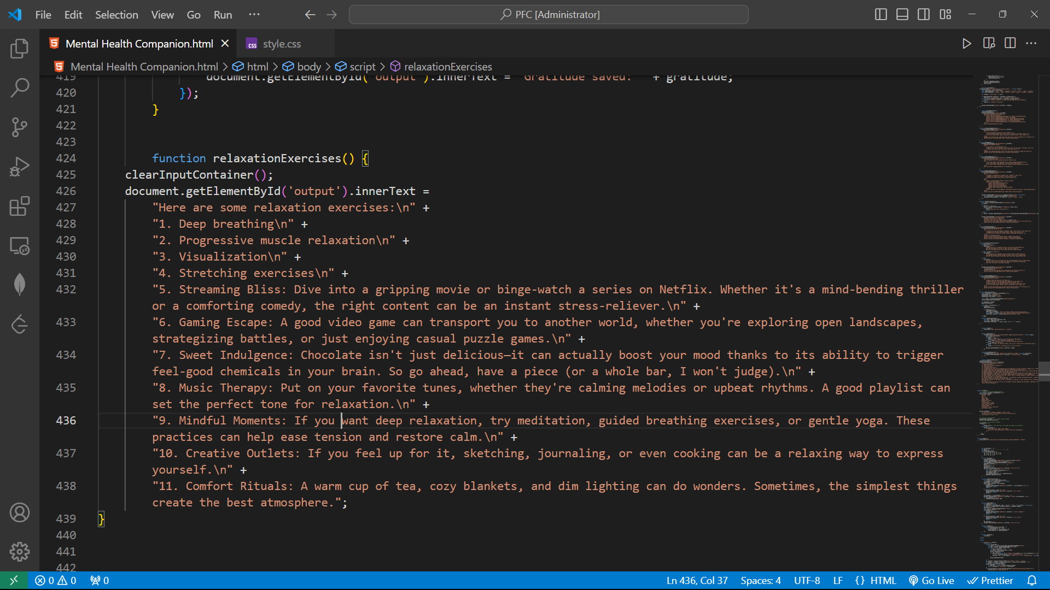

**Code Snippet for Game Button**

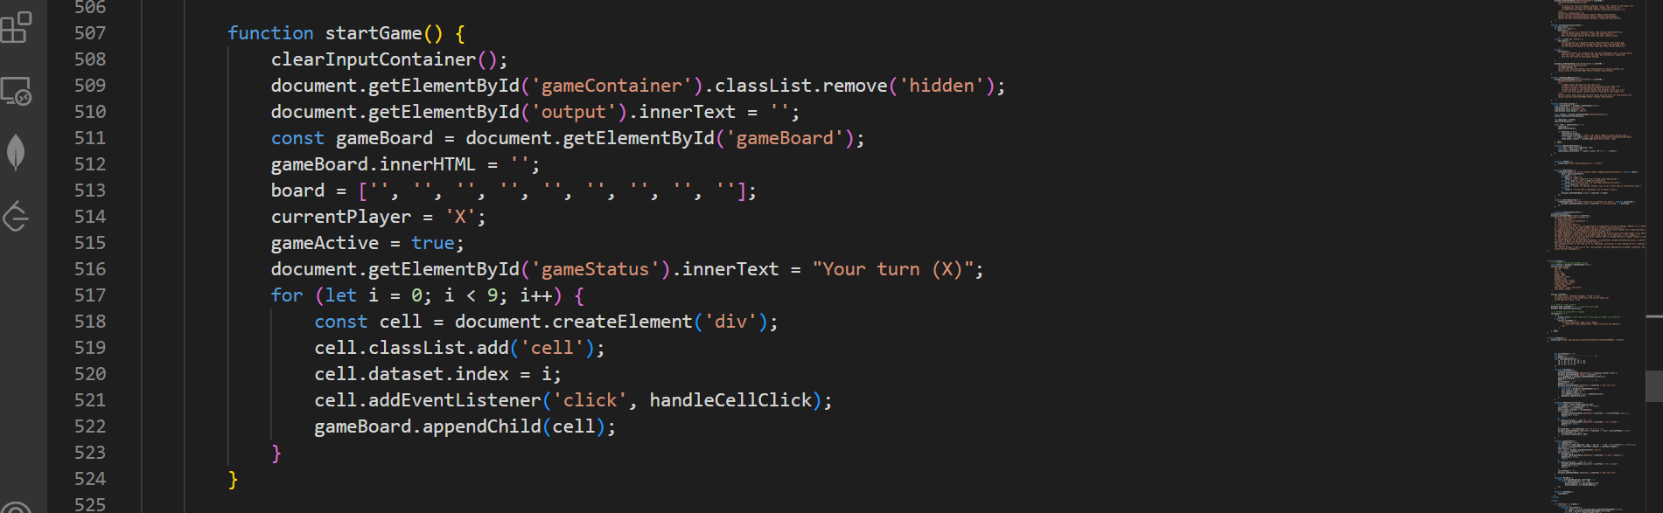

**Code Snippet for Help Button**



**Code Snippet for Sign Up Button**

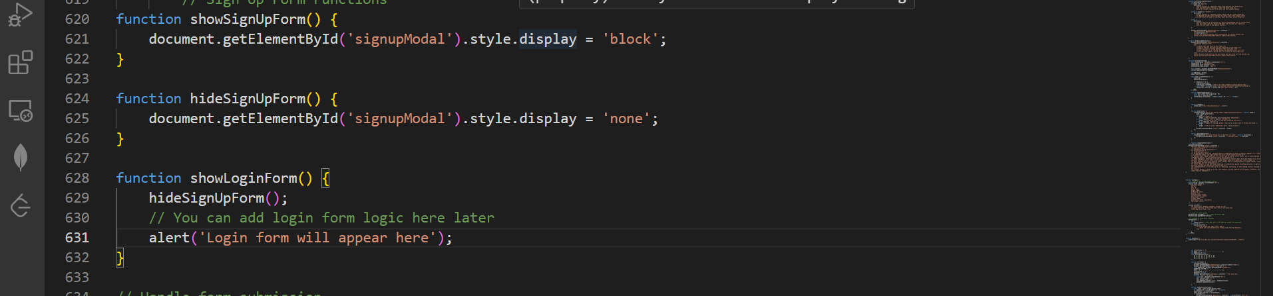

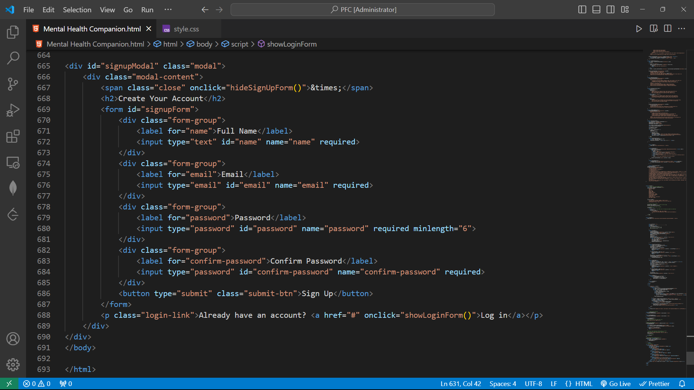

# CHAPTER 7 TESTING

The testing of the Mental Health Companion was primarily focused on ensuring the basic functionality of each feature within a standard web browser environment.

* **Testing Strategy -** Manual testing was conducted by the development team to verify that each feature performed as intended. This involved testing user input, the display of information, and the basic interactive elements.
* **Test Cases (Examples)**
  + Successfully entering text into the Journal Entry field.
  + Navigating through the text-based Relaxation Exercises.
  + Receiving a response from the basic "AI Chat."
  + Selecting a mood in the Mood Tracker.
  + Entering text in the Gratitude Journal.
  + Viewing the list of Self-Care Tips.
  + Playing and completing a game of Tic Tac Toe.
* **Observed Results -** The testing generally confirmed that the core functionalities of each feature were working as designed within the limitations of the technology stack. Some minor UI adjustments may have been identified and addressed during this phase.

**CHAPTER 8 ETHICAL CONSIDERATIONS AND PRIVACY**

Given the sensitive nature of mental well-being, ethical considerations and user privacy were important aspects of the development process, even within the constraints of a purely front-end application.

* **Data Privacy -** As the application is designed to run locally in the user's browser without any external server communication or database, user-generated content (such as journal entries or mood logs, if local storage were implemented) remains within the user's control and is not transmitted to any third party. This inherently provides a degree of privacy.
* **Limitations of the "AI Chat" -**  It is crucial to emphasize that the "AI Chat" functionality is rudimentary and provides only pre-programmed responses. Users must be clearly informed that this feature is not a substitute for professional mental health support and should not be relied upon for diagnosis or treatment. Disclaimers or clear informational text within the "Chat AI" interface would be necessary.

**Responsible Use -**  The application is intended to be a supportive tool for self-reflection and mood management. Users should be encouraged to seek professional help when needed and to view the Mental Health Companion as a supplementary resource rather than a replacement for qualified mental health professionals

In developing the **Mental Health Companion** platform, we recognize the profound responsibility that comes with handling sensitive mental health data and providing psychological support tools. Ethical considerations and user privacy form the cornerstone of our design philosophy, ensuring that every aspect of this application adheres to the highest standards of confidentiality, consent, transparency, and user autonomy. Given the deeply personal nature of mental health, we have implemented rigorous safeguards to protect users from potential harm, misuse of data, or unintended psychological consequences. Below, we outline in extensive detail the ethical framework and privacy protections that govern this platform.

**Data Privacy and Confidentiality**

**a. No Data Storage Policy**

The Mental Health Companion operates on a strict **zero-data-retention** principle. Unlike many digital health platforms that collect and store user information for analytics or personalization, we deliberately avoid storing any personal data, journal entries, mood logs, or meditation preferences. All inputs—whether journal reflections, mood updates, or gratitude lists—are processed in real-time and immediately discarded after the session ends. This ensures that even in the unlikely event of a security breach, there would be no sensitive user data to compromise.

**b. No Tracking or Profiling**

We do not employ cookies, tracking pixels, or behavioral analytics tools that monitor user activity across sessions. The platform does not create user profiles, track engagement metrics, or analyze patterns in emotional responses for commercial or research purposes. Our commitment to anonymity means that every interaction is treated as an isolated session, with no digital footprint left behind.

**c. Encryption and Secure Transmission**

Although no personal data is stored, any information temporarily processed during a session (such as journal text submitted for sentiment analysis) is encrypted in transit using **TLS (Transport Layer Security) protocols**, ensuring that data cannot be intercepted by third parties.

**d. Third-Party Integrations**

The platform includes a **Chat AI** feature that redirects users to an external AI service (Perplexity AI). We explicitly inform users that this is a third-party tool with its own privacy policies, and we do not control how those services handle data. Similarly, guided meditation resources link to external websites (Headspace, Calm, Insight Timer), and users are advised to review those platforms' privacy practices before engaging with them.

**User Consent and Autonomy**

**a. Informed Participation**

Before using any feature, users are presented with clear disclaimers explaining:

* The platform is **not a substitute for professional mental healthcare**.
* All inputs are **ephemeral** and not stored.
* The limitations of AI-driven support versus human therapy.

This ensures that users engage with the tool with realistic expectations about its capabilities and boundaries.

**b. Voluntary Engagement**

No feature requires mandatory data entry. Users can freely explore meditation guides, relaxation exercises, or games without disclosing personal feelings. Journaling and mood tracking are entirely optional, with no pressure to share sensitive emotions.

**c. Right to Disengage**

The **Exit App** function allows users to leave the platform immediately, with a reassuring message affirming their autonomy ("Take care. You are not alone."). We avoid dark patterns (e.g., manipulative prompts to continue engagement) that could pressure users into prolonged use.

**Psychological Safety and Harm Reduction**

**a. Content Moderation**

While journal entries are not stored, our sentiment analysis algorithm scans for **high-risk keywords** (e.g., self-harm, suicidal ideation). If detected, the platform:

1. **Does not** store or report the content (maintaining privacy).
2. **Displays urgent guidance** to contact a licensed professional or crisis hotline (e.g., "If you’re in distress, please reach out to a trusted person or call a helpline immediately").

**b. Avoiding Over-Dependence**

To prevent users from substituting this tool for professional care:

* **Journal responses** gently encourage seeking human support for persistent negative emotions.
* **Mood tracker disclaimers** remind users that fluctuations are normal but warrant professional attention if severe.
* **Meditation guides** clarify they are for relaxation, not treatment of clinical conditions like PTSD or severe anxiety disorders.

**c. Culturally Inclusive Design**

Meditation scripts, relaxation exercises, and affirmations avoid religious or cultural assumptions. Visualizations (beach, forest) are intentionally neutral to accommodate diverse backgrounds.

**Transparency and Accountability**

**a. Open-Source Code (Hypothetical)**

While this is a demo project, a real-world deployment would ideally open-source its codebase for public audit, allowing experts to verify:

* No hidden data collection.
* Ethical AI sentiment analysis (e.g., no biased labeling of emotions).

**b. No Commercial Exploitation**

* **No ads or sponsorships**: The platform does not monetize user attention or sell anonymized data.
* **No premium paywalls**: All features remain freely accessible.

**c. Clear Boundaries with AI**

The **Chat AI** redirect explicitly states that conversations are handled by third-party AI, which may have privacy trade-offs. We do not falsely anthropomorphize the tool (e.g., claiming it "understands" or "cares"), as this could foster unhealthy attachments.

**Legal and Compliance Frameworks**

**a. GDPR and HIPAA Alignment**

Though not storing data exempts us from stringent regulations, we voluntarily align with:

* **GDPR** principles: Right to erasure, data minimization.
* **HIPAA** guidelines: Encryption, no PHI (Protected Health Information) retention.

**b. Child and Vulnerable User Protections**

* No age verification is required (due to no data collection), but disclaimers advise parental guidance for minors.
* Crisis resources are prioritized over algorithmic responses for high-risk inputs.

**Continuous Ethical Review**

A hypothetical live deployment would establish:

* An **ethics advisory board** with mental health professionals to review updates.
* **User feedback channels** to report concerns about triggering content or privacy gaps.
* **Bias audits** for AI-driven features (e.g., ensuring mood analysis doesn’t pathologize normal emotions).

# CHAPTER 9 OUTPUT SCREEN

Overview of UI

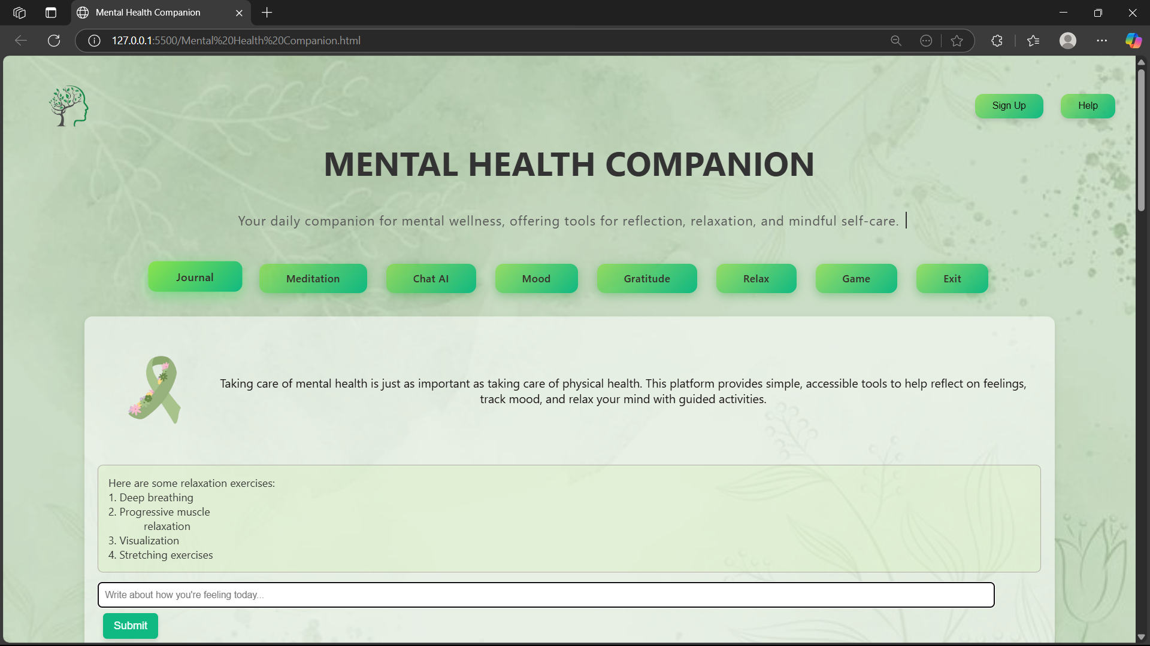

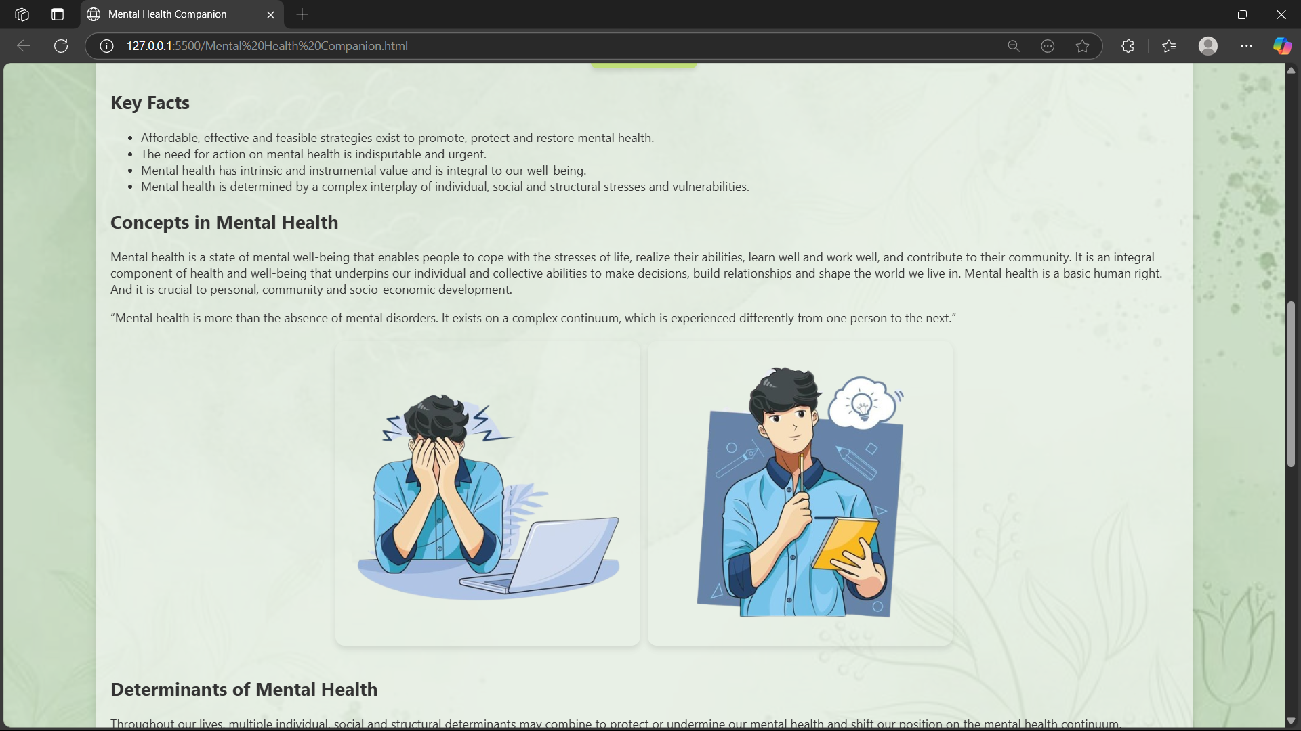

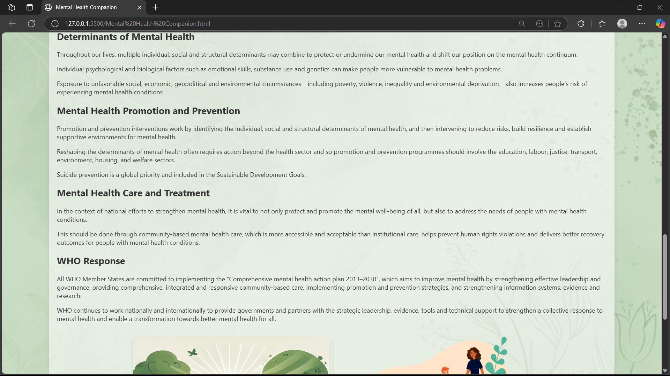

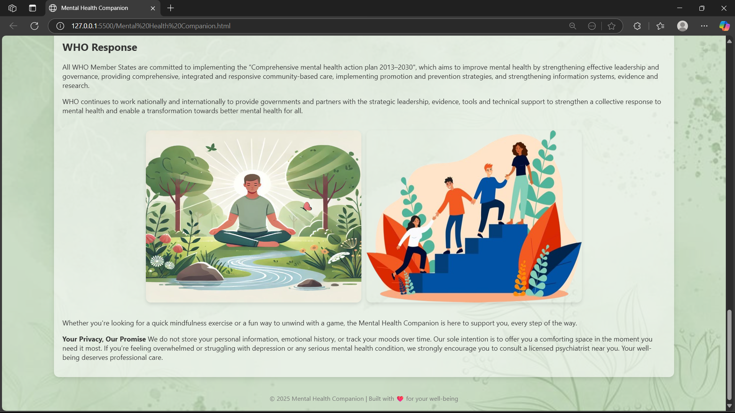

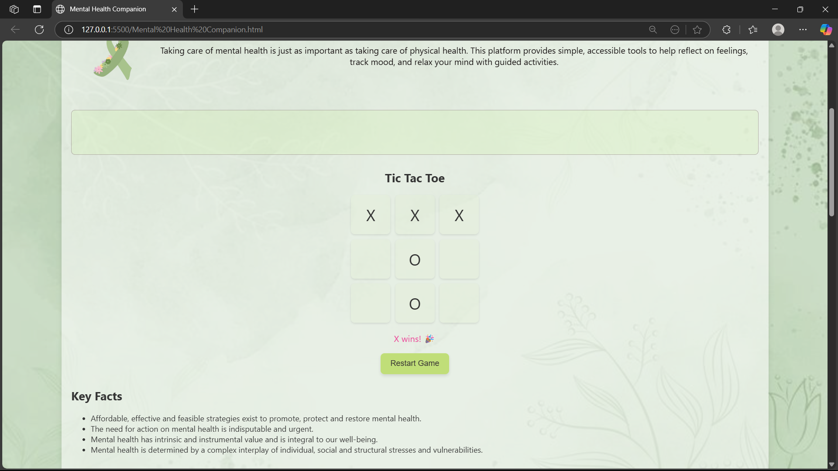

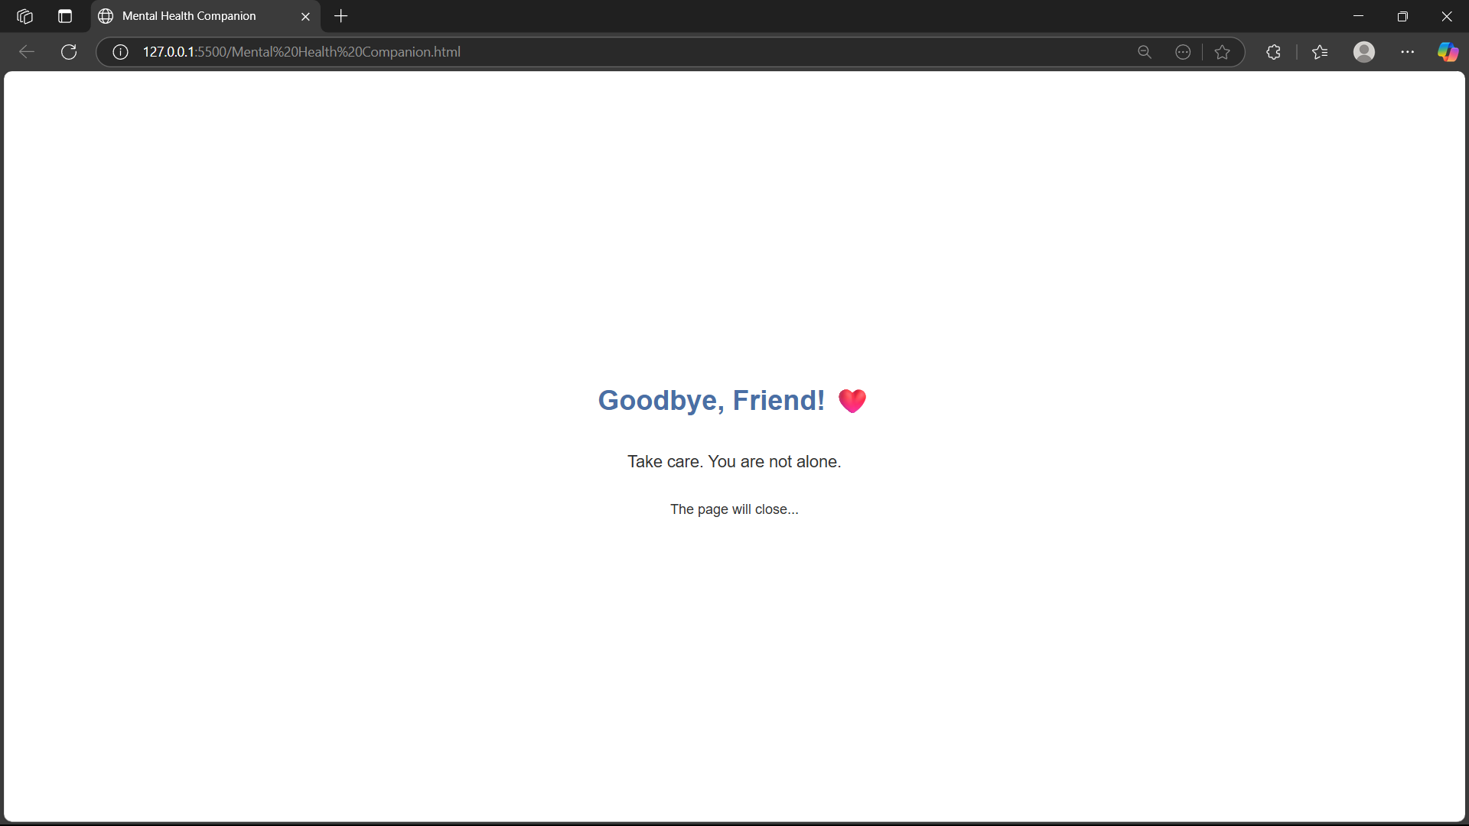

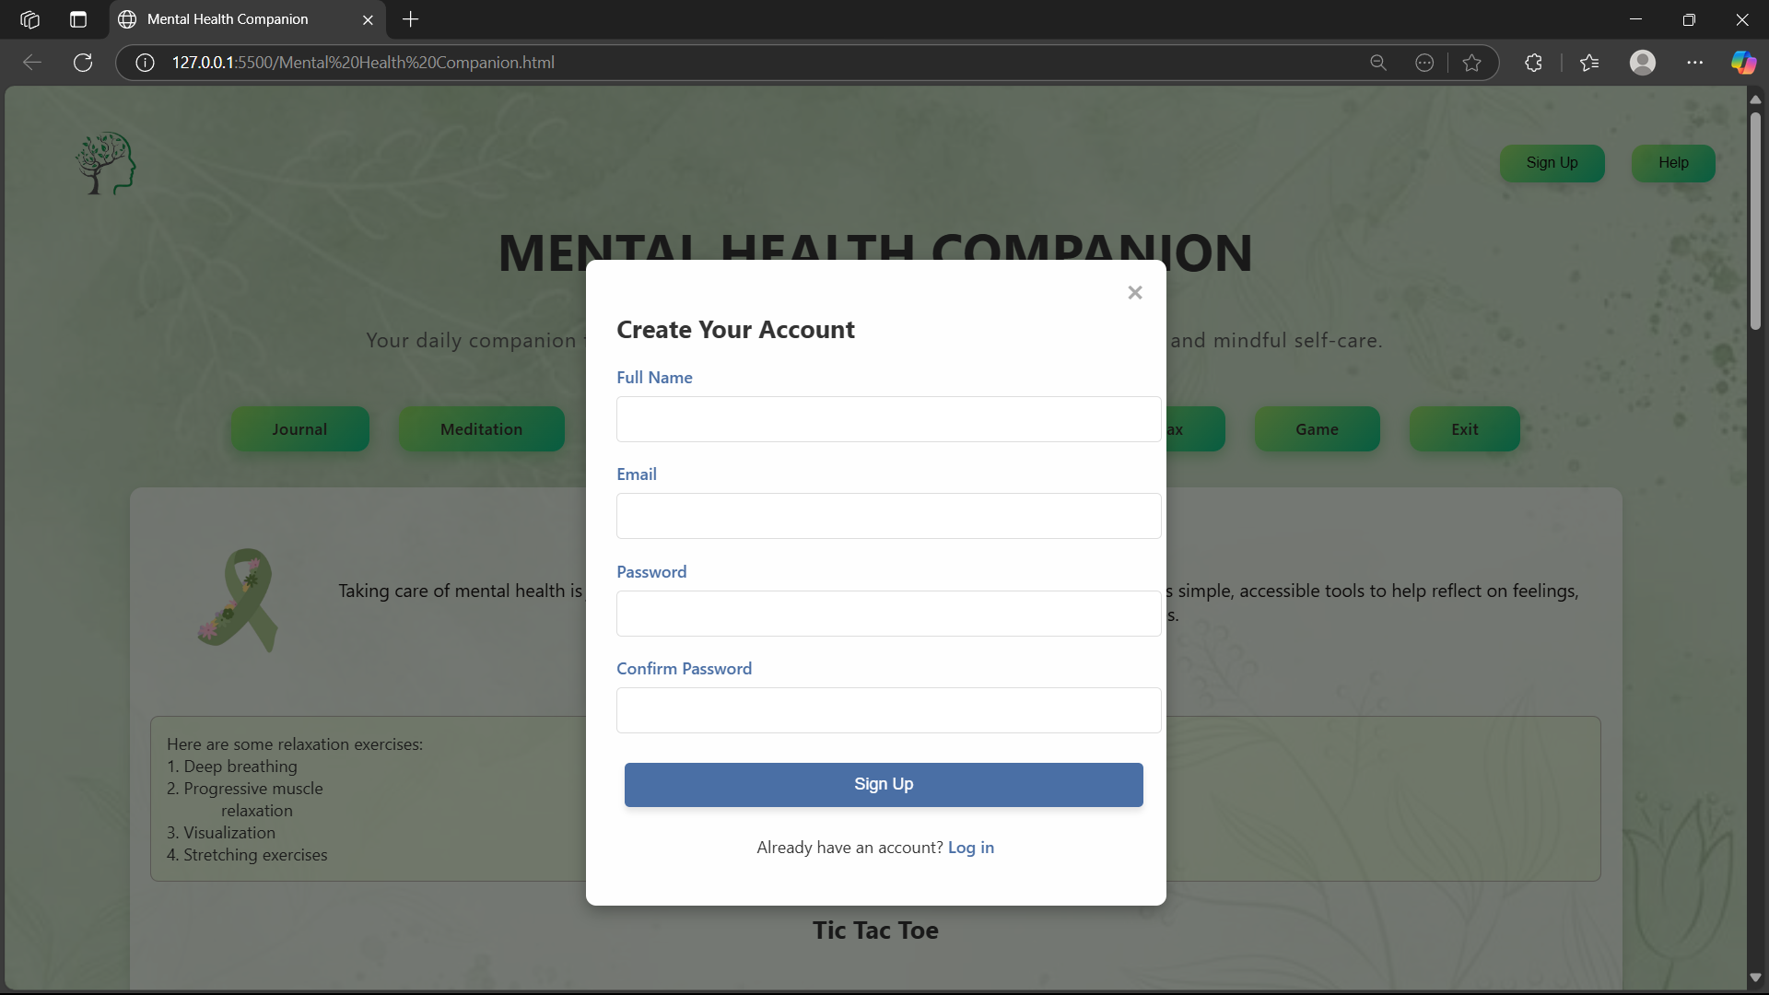

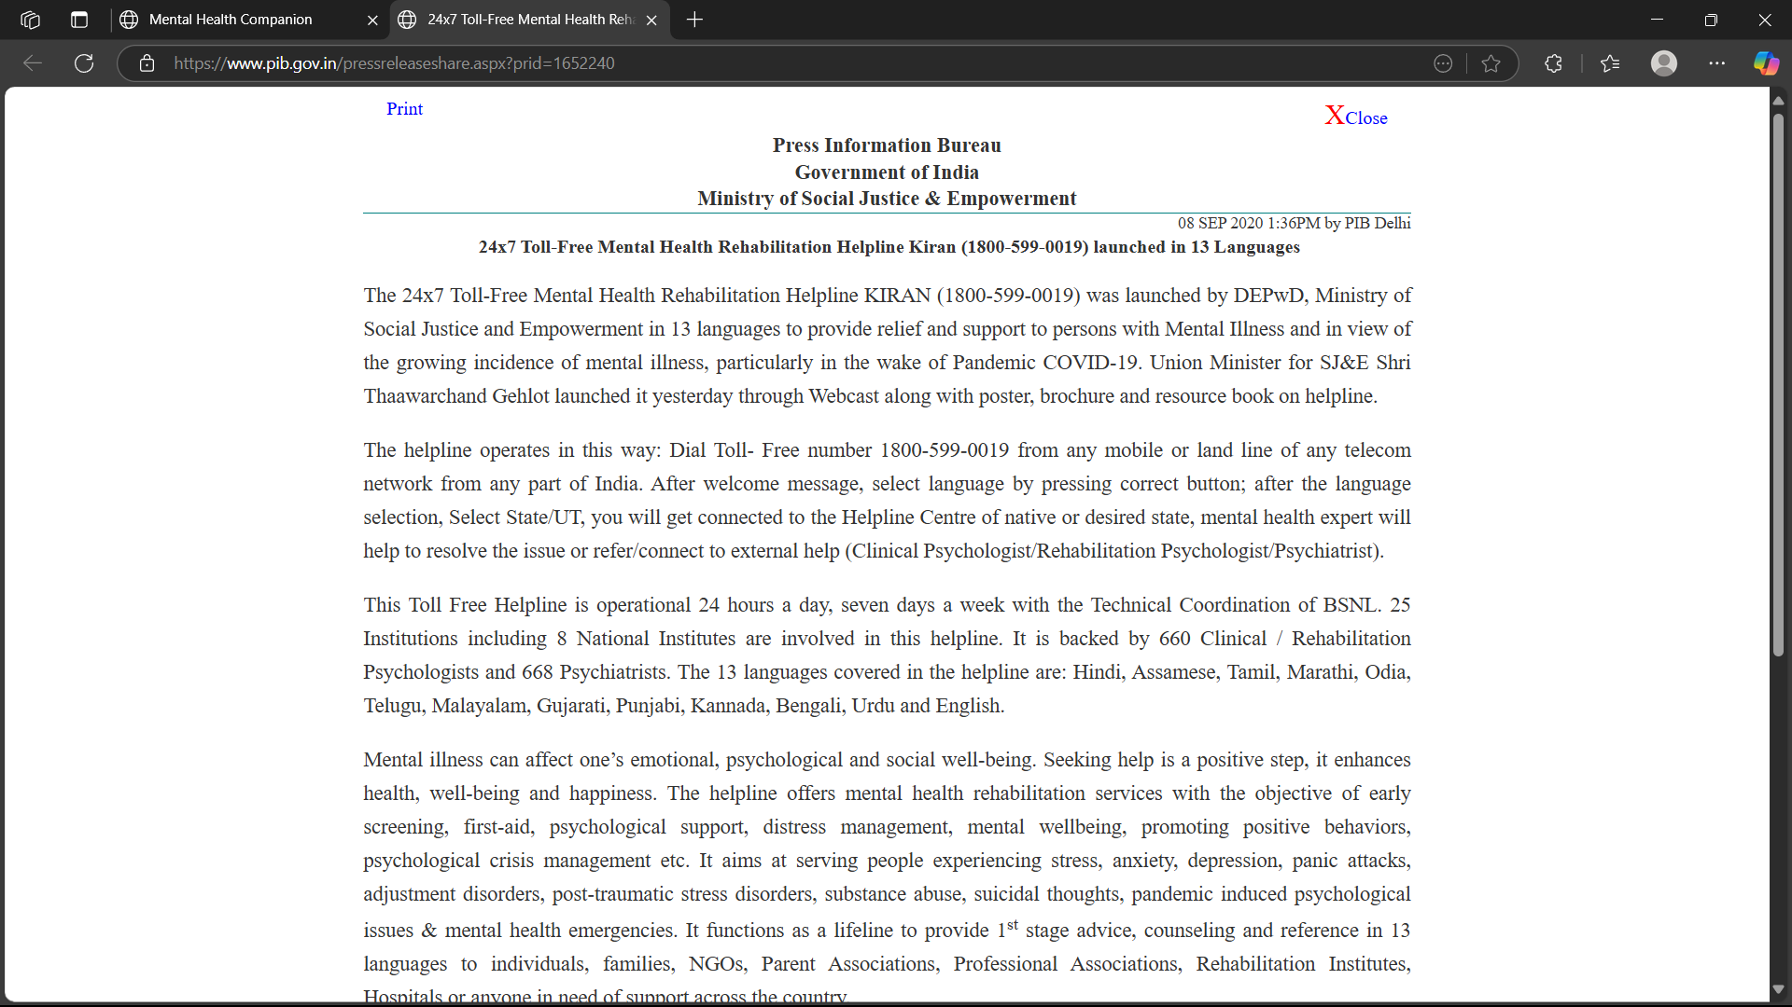

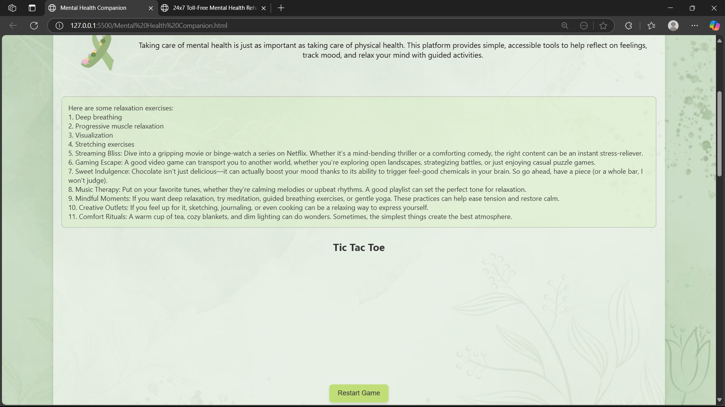

# CHAPTER 10 CONCLUSION

The Mental Health Companion web application represents a foundational effort to create an accessible and private digital tool for supporting mental well-being. Developed using only HTML, CSS, and JavaScript, it offers a range of features designed to encourage self-reflection, mood awareness, and engagement with basic self-care practices. While limited by the absence of a backend database and external API integration, the application provides a valuable starting point and highlights the potential of even simple web technologies to contribute to mental well-being. The project serves as a testament to the team's ability to create a functional application within specific technological constraints, laying the groundwork for potential future expansion and integration of more advanced features.

In bringing this Mental Health Companion project to its culmination, it is imperative to recognize the monumental significance of mental well-being in an era where the pressures of modern existence—relentless work demands, social media-induced anxiety, economic instability, and the lingering aftermath of global crises—have rendered emotional resilience not just a personal asset but a societal necessity. This platform stands as a beacon of hope, meticulously crafted to serve as a digital refuge where individuals, regardless of their background or circumstances, can find solace, guidance, and practical tools to navigate the turbulent waters of their inner lives. By integrating a multifaceted approach that includes journaling for self-reflection, guided meditations for mindfulness, mood tracking for emotional awareness, gratitude exercises for positivity reinforcement, relaxation techniques for stress alleviation, and even therapeutic gaming for momentary escape, this project transcends the limitations of conventional mental health resources by offering a holistic, user-centric experience tailored to diverse needs and preferences. The very foundation of this companion is rooted in the understanding that mental health is not a binary state of illness versus wellness but rather a fluid continuum where each individual’s journey is unique, requiring personalized strategies for coping, healing, and thriving.

In a world where access to professional mental health care remains a privilege for many—hampered by financial barriers, cultural stigma, or sheer lack of availability—this platform democratizes emotional well-being by providing free, immediate, and judgment-free support. The inclusion of psychoeducational content, such as key facts about mental health, determinants of psychological well-being, and global initiatives by organizations like the WHO, serves not only to inform but also to dismantle the pervasive myths and misconceptions that often shroud mental health discussions in silence and shame. Furthermore, the emphasis on privacy—ensuring users that their deepest fears, joys, and struggles are not stored, analyzed, or exploited—reinforces a critical ethical commitment to trust and confidentiality, which are so often lacking in today’s data-driven digital landscape.

The interactive elements of this project, such as the AI-powered chat redirect for real-time conversation, the Tic-Tac-Toe game designed to offer cognitive distraction during moments of distress, and the structured meditation guides that cater to varying levels of experience, collectively create an ecosystem where mental health management is not a burdensome chore but an engaging, even empowering, daily practice. The journaling feature, with its sentiment analysis that gently nudges users toward positive reinforcement or playful distraction when negative emotions are detected, exemplifies how technology can be harnessed to mimic the empathetic responsiveness of human support. Meanwhile, the mood tracker encourages users to develop greater emotional literacy, helping them identify patterns, triggers, and progress over time—an essential step in fostering long-term mental resilience.

However, it is crucial to acknowledge that while this Mental Health Companion serves as an invaluable tool for self-care, it is not a panacea nor a replacement for professional intervention when severe psychological distress arises. The platform’s deliberate encouragement for users to seek licensed help when needed underscores a responsible approach to mental health advocacy—one that recognizes the limits of digital solutions while still maximizing their potential to bridge gaps in care. Looking ahead, the future iterations of this project could expand into AI-driven personalized therapy suggestions, community support forums for shared healing, or even integration with wearable technology to monitor physiological stress signals, thereby creating an even more responsive and adaptive mental health ecosystem.

Ultimately, this project is more than just an application; it is a movement toward a world where mental health is regarded with the same urgency, respect, and resource allocation as physical health. It is a testament to the power of compassionate design, where technology does not isolate but connects, does not overwhelm but soothes, and does not judge but supports. In the grand tapestry of human experience—where joy and sorrow, hope and despair, strength and vulnerability are inextricably woven together—tools like the Mental Health Companion ensure that no one has to navigate their struggles alone. By fostering a culture of openness, self-awareness, and proactive care, this initiative plants the seeds for a future where emotional well-being is not an afterthought but a fundamental pillar of a fulfilling life. May it continue to evolve, reaching countless individuals in their moments of need, and may its existence remind us all that healing is not a solitary journey but a collective responsibility—one that begins with the simple yet radical act of paying attention to the mind, heart, and soul.

# CHAPTER 11 FUTURE ENHANCEMENTS

Despite its current limitations as a purely front-end application, the Mental Health Companion has the potential to offer several benefits to users seeking basic self-help tools. It provides a private and readily accessible platform for self-reflection, mood awareness, and engagement with simple relaxation and self-care practices. The inclusion of a lighthearted game offers a quick and easy way to potentially shift mood.

In terms of future directions, even within the scope of HTML, CSS, and JavaScript, several enhancements could be explored:

* **Enhanced "AI Chat" -** Expanding the library of pre-programmed responses to offer more varied and helpful interactions.
* **Basic Audio Integration -** If local audio files are included, JavaScript could be used to create a simple audio player for guided meditations.
* **Improved Mood Tracking Visualization -** Utilizing JavaScript charting libraries (if they can be implemented without external APIs) to provide users with a visual representation of their mood logs based on temporary in-browser data.
* **Local Storage Implementation -** Implementing JavaScript to utilize the browser's local storage to persist user-generated data (journal entries, mood logs, gratitude notes) across different browsing sessions.

Beyond the current technological constraints, future development could explore incorporating backend technologies and APIs to enable features such as secure user accounts, cloud-based data storage, personalized recommendations, integration with professional mental health resources, and more advanced AI-powered support.

**YOUR PRIVACY, OUR PROMISE**

We do not store your personal information, emotional history, or track your moods over time. Our sole intention is to offer you a comforting space in the moment you need it most. If you’re feeling overwhelmed or struggling with depression or any serious mental health condition, we strongly encourage you to consult a licensed psychiatrist near you. Your well-being deserves professional care.

On our website, we proudly integrate Perplexity as our chatbot of choice — not Google Gemini, not Microsoft Copilot, not China’s DeepSeek, and not even America’s ChatGPT. Instead, we rely on this innovative solution founded by an Indian-origin visionary, ensuring a truly homegrown approach to AI assistance.

Your privacy and data security are our top priorities. We do not store or save any of your personal data, and we deliberately avoid third-party services that compromise confidentiality. Even the Help button on our site redirects you to an official Indian government website, reinforcing our commitment to transparency and trust.

By choosing Perplexity, we ensure that your interactions remain safe, private, and secure — the Indian way.

**INDIVIAL CONTRIBUTIONS**

* **Ansh Saraswat -** Development of the Mental Health Companion web application. With logics in javascccript. And prepared detailed report.
* **Shreya Pancholi -** Development of the Mental Health Companion web application. With designing the website. And prepared detailed report.
* **Aryandeep Singh -** Formed the detailed report on the Mental Health Companion web application.

# REFERENCES

1. WHO. (2021). Mental health resources. https://www.who.int  
2. Headspace. https://www.headspace.com  
3. Calm. https://www.calm.com  
4. Smith, J. (2020). Digital tools for mental health. Journal of Health Informatics.  
5. Brown, K., & Taylor, R. (2019). Web-based interventions for mental wellness. Psychology & Technology.

# APPENDICES

<!DOCTYPE html>

<html lang="en">

<head>

<meta charset="UTF-8">

<title>Mental Health Companion</title>

<style>

body { font-family: Arial, sans-serif; margin: 0; padding: 0; line-height: 1.6; }

header, footer { background: #4a6fa5; color: white; padding: 15px; text-align: center; }

nav { background: #f0f0f0; padding: 15px; text-align: center; }

button { margin: 5px; padding: 10px 15px; background: #4a6fa5; color: white; border: none; border-radius: 4px; cursor: pointer; }

button:hover { background: #3a5a80; }

.hidden { display: none; }

.modal { display: none; position: fixed; z-index: 1; left: 0; top: 0; width: 100%; height: 100%; background-color: rgba(0,0,0,0.4); }

.modal-content { background-color: #fefefe; margin: 10% auto; padding: 20px; border: 1px solid #888; width: 80%; max-width: 500px; border-radius: 5px; }

.close { color: #aaa; float: right; font-size: 28px; font-weight: bold; cursor: pointer; }

.page { padding: 20px; margin: 20px auto; max-width: 800px; }

.section { margin-bottom: 30px; }

.quote { font-style: italic; border-left: 3px solid #4a6fa5; padding-left: 15px; margin: 15px 0; }

</style>

</head>

<body>

<header>

<h1>MENTAL HEALTH COMPANION</h1>

<p>Your daily companion for mental wellness</p>

</header>

<nav>

<button onclick="showPage('home')">Home</button>

<button onclick="showPage('resources')">Resources</button>

<button onclick="showPage('techniques')">Techniques</button>

<button onclick="showPage('about')">About</button>

<button onclick="showSignUpForm()">Sign Up</button>

<button onclick="openHelp()">Help</button>

</nav>

<main>

<!-- Home Page -->

<div id="home" class="page">

<div class="section">

<h2>Welcome to Your Mental Health Companion</h2>

<p>This platform provides tools to help you reflect on feelings, track mood, and relax your mind with guided activities.</p>

<div class="quote">"Mental health is not a destination, but a process. It's about how you drive, not where you're going."</div>

</div>

<div class="section">

<h3>Quick Access Tools</h3>

<button onclick="journalEntry()">Journal</button>

<button onclick="guidedMeditation()">Meditation</button>

<button onclick="moodTracker()">Mood Tracker</button>

<button onclick="startGame()">Relaxation Game</button>

</div>

<div id="output">Select a tool to begin your wellness journey</div>

<div id="inputContainer"></div>

<div id="gameContainer" class="hidden">

<h3>Tic Tac Toe</h3>

<div id="gameBoard"></div>

<p id="gameStatus"></p>

<button onclick="resetGame()">Restart</button>

</div>

</div>

<!-- Resources Page -->

<div id="resources" class="page" style="display:none;">

<div class="section">

<h2>Mental Health Resources</h2>

<h3>Crisis Hotlines</h3>

<ul>

<li>National Suicide Prevention Lifeline: 988</li>

<li>Crisis Text Line: Text HOME to 741741</li>

<li>Veterans Crisis Line: 988 then press 1</li>

</ul>

<h3>Recommended Reading</h3>

<ul>

<li>"The Happiness Trap" by Russ Harris</li>

<li>"Feeling Good" by David Burns</li>

<li>"The Body Keeps the Score" by Bessel van der Kolk</li>

</ul>

<h3>Online Communities</h3>

<ul>

<li>7 Cups of Tea (7cups.com)</li>

<li>Mental Health America Forum (mhanet.org)</li>

<li>Reddit Mental Health Support Communities</li>

</ul>

</div>

</div>

<!-- Techniques Page -->

<div id="techniques" class="page" style="display:none;">

<div class="section">

<h2>Mental Health Techniques</h2>

<h3>Cognitive Behavioral Techniques</h3>

<p>Identify negative thought patterns and replace them with more balanced thoughts using these methods:</p>

<ul>

<li>Thought Records - Track automatic negative thoughts</li>

<li>Behavioral Activation - Schedule positive activities</li>

<li>Graded Exposure - Gradually face fears</li>

</ul>

<h3>Mindfulness Practices</h3>

<ul>

<li>5-4-3-2-1 Grounding Technique</li>

<li>Body Scan Meditation</li>

<li>Mindful Breathing Exercises</li>

</ul>

<h3>Daily Wellness Habits</h3>

<ul>

<li>Sleep hygiene practices</li>

<li>Physical activity routines</li>

<li>Nutrition for mental health</li>

</ul>

</div>

</div>

<!-- About Page -->

<div id="about" class="page" style="display:none;">

<div class="section">

<h2>About This Project</h2>

<p>The Mental Health Companion was created to provide accessible mental health support tools to everyone.</p>

<h3>Our Mission</h3>

<p>To reduce barriers to mental health support by providing free, easy-to-use tools that promote emotional well-being.</p>

<h3>Privacy Policy</h3>

<p>We do not store your personal information or journal entries. All activities are private to your device.</p>

<h3>Disclaimer</h3>

<p>This is not a substitute for professional mental health care. If you're in crisis, please contact a licensed professional.</p>

</div>

</div>

</main>

<footer>

<p>© 2025 Mental Health Companion | Built with care for your well-being</p>

<p>Contact: support@mentalhealthcompanion.org</p>

</footer>

<!-- Sign Up Modal -->

<div id="signupModal" class="modal">

<div class="modal-content">

<span class="close" onclick="hideSignUpForm()">&times;</span>

<h2>Create Your Account</h2>

<form id="signupForm">

<div style="margin-bottom:15px;">

<input type="text" id="name" placeholder="Full Name" required style="width:100%; padding:8px;">

</div>

<div style="margin-bottom:15px;">

<input type="email" id="email" placeholder="Email" required style="width:100%; padding:8px;">

</div>

<div style="margin-bottom:15px;">

<input type="password" id="password" placeholder="Password" required style="width:100%; padding:8px;">

</div>

<div style="margin-bottom:15px;">

<input type="password" id="confirm-password" placeholder="Confirm Password" required style="width:100%; padding:8px;">

</div>

<button type="submit" style="width:100%; padding:10px;">Sign Up</button>

</form>

</div>

</div>

<script>

// Page Navigation

function showPage(pageId) {

document.querySelectorAll('.page').forEach(page => {

page.style.display = 'none';

});

document.getElementById(pageId).style.display = 'block';

}

// Core functions

function journalEntry() {

const entry = prompt("Write about your feelings today:");

if (entry) {

const lowerEntry = entry.toLowerCase();

if (lowerEntry.includes('sad') || lowerEntry.includes('anxious')) {

alert("Thank you for sharing. Consider trying a relaxation exercise.");

} else if (lowerEntry.includes('happy') || lowerEntry.includes('good')) {

alert("Great to hear you're doing well!");

} else {

alert("Thank you for your journal entry.");

}

}

}

function guidedMeditation() {

const choice = prompt("Choose meditation:\n1. Breathing\n2. Body Scan\n3. Visualization");

if (choice === "1") alert("Focus on your breath for 5 minutes...");

else if (choice === "2") alert("Scan your body from head to toe...");

else if (choice === "3") alert("Imagine a peaceful place...");

}

function moodTracker() {

const mood = prompt("Rate your mood (1-5, where 1 is poor and 5 is excellent):");

if (mood) {

const moodNum = parseInt(mood);

if (moodNum < 3) {

alert("Consider trying a relaxation technique or reaching out for support.");

} else {

alert("Great! Keep up whatever is working for you.");

}

}

}

function relaxationExercises() {

alert("Try these quick exercises:\n\n1. Box Breathing (4-4-4-4)\n2. Progressive Muscle Relaxation\n3. 5-4-3-2-1 Grounding Technique");

}

function exitApp() {

if(confirm("Are you sure you want to exit?")) {

document.body.innerHTML = "<div style='text-align:center;padding:50px;'><h1>Take care of yourself!</h1><p>Remember, your mental health matters.</p></div>";

setTimeout(() => { try{window.close();}catch(e){} }, 2000);

}

}

function openHelp() {

window.open("https://www.who.int/news-room/fact-sheets/detail/mental-health-strengthening-our-response", "_blank");

}

// Tic Tac Toe game

let currentPlayer = 'X', board = ['','','','','','','','',''], gameActive = true;

const winningCombos = [[0,1,2],[3,4,5],[6,7,8],[0,3,6],[1,4,7],[2,5,8],[0,4,8],[2,4,6]];

function startGame() {

document.getElementById('gameContainer').classList.remove('hidden');

const gameBoard = document.getElementById('gameBoard');

gameBoard.innerHTML = '';

board = ['','','','','','','','',''];

currentPlayer = 'X';

gameActive = true;

document.getElementById('gameStatus').innerText = "Your turn (X)";

for (let i = 0; i < 9; i++) {

const cell = document.createElement('div');

cell.style.width = '60px';

cell.style.height = '60px';

cell.style.border = '1px solid #333';

cell.style.display = 'inline-block';

cell.style.textAlign = 'center';

cell.style.lineHeight = '60px';

cell.style.fontSize = '24px';

cell.style.cursor = 'pointer';

cell.dataset.index = i;

cell.addEventListener('click', handleCellClick);

gameBoard.appendChild(cell);

}

}

function handleCellClick(e) {

const index = e.target.dataset.index;

if (!gameActive || board[index] !== '') return;

board[index] = currentPlayer;

e.target.innerText = currentPlayer;

if (checkWin()) {

document.getElementById('gameStatus').innerText = `${currentPlayer} wins!`;

gameActive = false;

return;

}

if (board.every(cell => cell !== '')) {

document.getElementById('gameStatus').innerText = "Draw!";

gameActive = false;

return;

}

currentPlayer = currentPlayer === 'X' ? 'O' : 'X';

document.getElementById('gameStatus').innerText = `Player ${currentPlayer}'s turn`;

if (currentPlayer === 'O') setTimeout(computerMove, 500);

}

function computerMove() {

if (!gameActive) return;

let available = board.map((val, idx) => val === '' ? idx : null).filter(v => v !== null);

let choice = available[Math.floor(Math.random() * available.length)];

board[choice] = 'O';

document.querySelectorAll('.cell')[choice].innerText = 'O';

if (checkWin()) document.getElementById('gameStatus').innerText = `O wins!`;

else if (board.every(cell => cell !== '')) document.getElementById('gameStatus').innerText = "Draw!";

else {

currentPlayer = 'X';

document.getElementById('gameStatus').innerText = "Your turn (X)";

}

}

function checkWin() {

return winningCombos.some(combo => board[combo[0]] !== '' && board[combo[0]] === board[combo[1]] && board[combo[1]] === board[combo[2]]);

}

function resetGame() { startGame(); }

// Sign Up Form

function showSignUpForm() { document.getElementById('signupModal').style.display = 'block'; }

function hideSignUpForm() { document.getElementById('signupModal').style.display = 'none'; }

document.getElementById('signupForm').addEventListener('submit', function(e) {

e.preventDefault();

if (document.getElementById('password').value !== document.getElementById('confirm-password').value) {

alert('Passwords do not match!');

return;

}

alert('Account created successfully!');

hideSignUpForm();

this.reset();

});

window.onclick = function(e) {

if (e.target == document.getElementById('signupModal')) hideSignUpForm();

}

// Initialize

showPage('home');

</script>

</body>

</html>